

“COLLEGE EVENT ENROLLMENT SYSTEM”

Project Report submitted in partial fulfillment of the requirements for the award of the degree of

BACHELOR OF COMPUTER APPLICATIONS (BCA)



Submitted By

YASHASWI P

20CS1K4237

Under the guidance of

Dr. HUBERT SHANTHAN BJ

DEPARTMENT OF COMPUTER SCIENCE (UG) BCA PROGRAMME
KRISTU JAYANTI COLLEGE (Autonomous)
K. Narayanapura, Kothanur P.O., Bangalore – 560077



DEPARTMENT OF COMPUTER SCIENCE (UG)

CERTIFICATE OF COMPLETION

This is to certify that the project entitled “COLLEGE EVENT ENROLLMENT SYSTEM ”has been satisfactorily completed by YASHASWI P, 20CS1K4237 in partial fulfillment of the award of the Bachelor of Computer Applications degree requirements prescribed by Kristu Jayanti College (Autonomous) Bengaluru (Affiliated to Bangalore North University)during the academic year 2020 -21.

Internal Guide Head of the Department

Valued by Examiners

1: Centre: Kristu Jayanti College

2: Date:

DECLARATION

I, YASHASWI P, 20CS1K4237 hereby declare that the project work entitled ‘COLLEGE EVENT ENROLLMENT SYSTEM’ is an original project work carried out by me, under the guidance of Dr. HUBERT SHANTHAN BJ

This project work has not been submitted earlier either to any University / Institution or any other body for the fulfillment of the requirement of a course of study.

Signature

(YASHASWI P)

Place: Date:

ACKNOWLEDGEMENT

The success of the project depends upon the efforts invested. It’s my duty to acknowledge and thank the individuals who has contributed in the successful completion of the project. I take this opportunity to express my profound and whole hearted thanks to Rev. Fr. Dr.AUGUSTINE GEORGE, PRINCIPAL, KRISTU JAYANTI COLLEGE, BANGALORE for providing ample facilities made to undergo my project successfully.

I express my deep sense of gratitude and sincere thanks to our Head of the Department Prof. SEVUGA PANDIAN for his valuable advice.

I feel immense pleasure to thank my respected guide Dr. HUBERT SHANTHAN BJ
for sustaining Interest and providing dynamic guidance in aiding me to complete this project immaculately andimpeccably and for being the source of my strength and confidence.

It is my dutyto express my thanks to all Teaching and Non-Teaching Staff members of Computer science department who offered me help directly or indirectly by their suggestions. The successful completion of my project would not have been possible without my parent’s Sacrifice, guidance and prayers. I take this opportunity to thank everyone for their continuous Encouragement. I convey my thankfulness to all my friends who were with me to share my happiness and agony.

Last but not the least I thank almighty God for giving me strength and good health throughoutmy project and enabling me to complete it successfully.
TABLE OF CONTENTS

Sl. No | Topic | Page No
1  1.1  1.2  2  2.1  2.2  2.3  3  3.1  3.2  3.3  3.4  4  4.1  4.2  5  5.1  5.2  5.3  6  7  8  9  10  11 | Introduction  Problem Definition  Scope of the Project  System Study  Existing System Feasibility Study Proposed System  System Design  ER Diagram DFD[lev0, lev1] Gantt Chart  Input / Output Design  System Configuration  Hardware Requirements  Software Requirements  Details of Software  Overview of Frontend  Overview of Backend  Testing  Conclusion and Future Enhancement  Bibliography  APPENDICES A-Table Structure APPENDICES B-Screenshots APPENDICES C-Sample Report of test cases | 1  2  4  6  10  19  20  28  29  31  39  42  43  44  46  51

KRISTU JAYANTI COLLEGE(AUTONOMOUS) 20CS1K4237

INTRODUCTION

1.1 PROBLEM DEFINITION

The main objective of College Event Enrollment System is to automate the manual registration process through online. It can manage all the details of different kinds of events and provides up- to-date information of the events, which will assist the students with necessary information about the events. The main purpose of the project is to build an application system to reduce the manual work.

1.2 SCOPE OF THE PROJECT

The software maintains the record of each student. The information about each student should be manually be entered by the admin
• The main objective of the software is to condense the manual work.
• Admin is the only one who can upload the event, verify registered students, delete the events. Such as (add, edit, update, and delete) operations are performed by the Admin.

1.3 MODULES IN THE SOFTWARE

1. Register From

2. Login Form

3. Event Information

4. Student Registration

5. Feed Back

6. Report generation

1 | P a g e
KRISTU JAYANTI COLLEGE(AUTONOMOUS) 20CS1K4237

2. SYSTEM STUDY

2.1 Existing System

The College event enrollment system helps to manage and develop events and also helps students to find list of events and register according to their choice. The project provides most of the basic functionality required for an event.

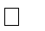
Event module: This module provides list of information about the different kinds of events. Students can search and register for event of their choices.
Feedback : This module helps to collect the feedback from the students.

Report generation: This helps to generate the reports of

2.2 Feasibility Study

A feasibility study is an analysis of how successfully a project can be completed, accounting for factors that affect it such as economic, technological, legal and scheduling factors. Project managers use feasibility studies to determine potential positive and negative outcomes of a project before investing a considerable amount of time and money introits.Feasibility study tests the viability of an idea, a project or even a new business. The goal of a feasibility study is to place emphasis on potential problems that could occur if a project is pursued and determine if, after all significant factors are considered, the project should be pursued. Feasibility studies also allow a business to address where and how it will operate, potential obstacles, competition and the funding needed to get the business up and running
The project “COLLEGE EVENT ENROLLMENT SYSTEM” can be designed and developed using .Net framework. The content, language is feasible to us and the portal can be developed based on the requirements. Components of feasible study:

Components of Feasibility study: Economic
FeasibilityTechnical

feasibility
2 | P a g e

3 | P a g e
KRISTU JAYANTI COLLEGE(AUTONOMOUS) 20CS1K4237

Operational feasibility

Schedule Feasibility

Every project is feasible for given unlimited resources and infinitive time. Feasibility study is an evaluation of the proposed system regarding its workability, impact on the organization, ability to meet the user needs and effective use of resources. Thus when a new application is proposed it normally goes through a feasibility study before it is approved for development. Feasibility and risk analysis are related in many ways. The feasibility analysis in this project has been discussed below based on the above mentioned components of feasibility.
SCHEDULE:

Time duration of this project requires 60 days covering 10days for requiring gathering,

10 days for design, and 20 days for developing, 10 days for testing and 10 days for implementation.
Resource persons are Yashaswi P and Sneha Mandira R

OPERATIONAL:

• Reduction of paper work.
• Human effort or Manual Labor can be reduced drastically.
• Major operations that are done manually can be done within a matter of seconds.
• Data storing is easier and backup is available.
ECONOMIC:

Later on we add more features and increase our benefit.

2.3 PROPOSED SYSTEM

The primary objective of proposed system is to automate student Event registration procedure. It can overcome all the limitations of the existing system. The system provides proper security. Implementation of proposed system will reduce the work load of all those involved as a data can now be managed with proper authentication and authorization instead of being hard copied and accessible to everyone. The software manages the complete record of the students.
Advantages of proposed system over existing system:

• Manages the complete record of students
• Easily maintainable

4 | P a g e
KRISTU JAYANTI COLLEGE(AUTONOMOUS) 20CS1K4237

• Faster access of data
• Reduces time
• Easy to handle
• Duplication of information is curbed
• And lastly secure and reliable
3. SYSTEM DESIGN

In the design phase the architecture is established. This phase starts with the requirement document delivered by the requirement phase and maps the requirements into architecture. The architecture defines the components, their interfaces and behaviors.
The deliverable design document is the architecture. The design document describes a plan to implement the requirements. This phase represents the ``how'' phase. Details on computer programming languages and environments, machines, packages, application architecture, distributed architecture layering, memory size, platform, algorithms, data structures, global type definitions, interfaces, and many other engineering details are established. The design may include the usage of existing components. In our approach, the team, given a complete requirement document, must also indicate critical priorities for the implementation team. A critical implementation priority leads to atask that has to be done right. If it fails, the product fails. If it succeeds, the product might succeed. At the very least, the confidence level of the team producing a successful product will increase. This will keep the implementation team focused. Exactly how this information is conveyed is a skill based on experience more than a science based on fundamental foundations. System design is the process of defining the architecture components, modules, interfaces, and data for a system to satisfy specified requirements. Systems design could be seen as the application of systems theory to product development. There is some overlap with the disciplines of systems analysis, systems architecture and systems engineering. If the broader topic of product development “blends the perspective of marketing, design, and manufacturing into a single approach to product development," then design is the act of taking the marketing information and creating the design of the product to be manufactured. Systems design is therefore the process of defining and developing systems to satisfy specified requirements of the
user.

5 | P a g e
KRISTU JAYANTI COLLEGE(AUTONOMOUS) 20CS1K4237

Until the 1990s, systems design had a crucial and respected role in the data processing industry. In the 1990s, standardization of hardware and software resulted in the ability to
build modular systems. The increasing importance of software running on generic platforms has enhanced the discipline of software engineering.
Design methods are becoming the most widely used methods for computer systems design. The

UML has become the standard language in objectoriented analysis and design. It

is widely used for modeling software systems and is increasingly used for high designing non- software systems and organizations.

Architectural design:

The architectural design of a system emphasizes the design of the system architecture that describes the structure, behavior and more views of that system and analysis.
Logical design:

The logical design of a system pertains to an abstract representation of the data flows, inputs and outputs of the system. This is often conducted via modelling, using an over- abstract (and sometimes graphical) model .of the actual system. In the context of systems, designs are included. Logical design includes entity-relationship diagrams (ER diagrams).
Physical design:

The physical design relates to the actual input and output processes of the system. This is explained in terms of how data is input into a system, how it is verified/authenticated, how it is processed, and how it is displayed. In physical design, the following requirements about the system are decided. 1. Input requirement, 2. Output requirements, 3. Storage requirements, 4. Processing requirements,
5. System control and backup or recovery.

Put another way, the physical portion of system design can generally be broken down into three sub-tasks:
1. User Interface Design 2. Data Design 3. Process Design

User Interface Design is concerned with how users add information to the system and with how the system presents information back to them. Data Design is concerned with how the data is represented and stored within the system. Finally, Process Design is concerned with how data
moves through the system, and with how and where it is validated, secured and/or transformed as

6 | P a g e
KRISTU JAYANTI COLLEGE(AUTONOMOUS) 20CS1K4237

it flows into, through and out of the system. At the end of the system design phase, documentation describing the three sub-tasks is produced and made available for use in the next phase. Physical design, in this context, does not refer to the tangible physical design of an information system. To use an analogy, a personal computer's physical design involves input via a keyboard, processing within the CPU, and output viaa monitor, printer, etc. It would not concern the actual layout of the tangible hardware, which for a PC would be a monitor, CPU, motherboard, hard drive, modems, video/graphics cards, USB slots, etc. It involves a detailed design of a user and a product database structure processor and a control processor. The H/S personal specification is developed for the proposed system.
3.1 E-R DIAGRAMS

An entity relationship diagram (ERD) shows the relationships of entity sets stored in a database. An entity in this context is a component of data. In other words, ER diagrams illustrate the logical structure of databases.
At first glance an entity relationship diagram looks very much like a flowchart. It is the specialized symbols, and the meanings of those symbols, that make it unique.
Because this ER tutorial focuses on beginners below are some tips that will help you build effective ER diagrams:
1. Identify all the relevant entities in a given system and determine the relationships among these entities.

2. An entity should appear only once in a particular diagram.
3. Provide a precise and appropriate name for each entity, attribute, and relationship in the diagram. Terms that are simple and familiar always beats vague, technical- sounding words.

In naming entities, remember to use singular nouns. However, adjectives may be used to distinguish entities belonging to the same class (part-time employee and full time employee, for example). Meanwhile attribute names must be meaningful, unique, system-independent, and easily understandable.
4. Remove vague,redundant or unnecessary relationships between entities.

5. Never connect a relationship to another relationship.
6. Make effective use of colors.You can use colors to classify similar entities or to highlight key areas in your diagrams.

7 | P a g e
KRISTU JAYANTI COLLEGE(AUTONOMOUS) 20CS1K4237

You can draw entity relationship diagrams manually, especially when you are just informally showing simple systems to your peers. However, for more complex systems and for external audiences, you need diagramming software such as Creately’s to craft visually engaging and precise ER diagrams. The ER Diagram Software offered by Creately as an online service is pretty easy to use and is a lot more affordable than purchasing licensed software. It is also perfectly suited for development teams because of its strong support for collaboration.
The History of Entity Relationship Diagrams

Peter Chen developed ERDs in 1976. Since then Charles Bachman and James Martin have added some slight refinements to the basic ERD principles.
Structure of an Entity Relationship Diagram with Common

ERD Notations

An entity relationship diagram is a means of visualizing how the information a system produces is related. There are five main components of an ERD:
• Entities, which are represented by rectangles. An entity is an object or concept about which you want to store information.

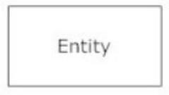

• Actions, which are represented by diamond shapes, show how two entities share information in the database. In some cases, entities can be self-linked. For example, employees
can supervise.

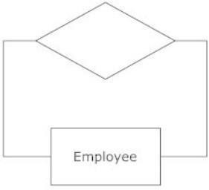

8 | P a g e
KRISTU JAYANTI COLLEGE(AUTONOMOUS) 20CS1K4237

• Attributes, which are represented by ovals. A key attribute is the unique, distinguishing characteristic of the entity. For example, an employee's social security number might be the

employee.

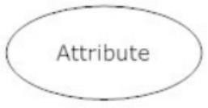

A multivalued attribute can have more than one value. For example, an employee entity can have multiple skill values. A derived attribute is based on another attribute.
For example, an employee's monthly salary is based on the employee's annual salar

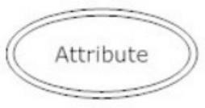

• Connecting lines, solid lines that connect attributes to show the relationships of entities in the diagram.

• Cardinality specifies how many instances of an entity relate to one instance of another entity. Ordinarily is also closely linked to cardinality. While cardinality specifies the

occurrences of a relationship, ordinality describes the relationship as either mandatory or optional.
In other words, cardinality specifies the maximum number of relationships and ordinality specifies absolute number of Relationship.
There are many notation styles that express cardinality.

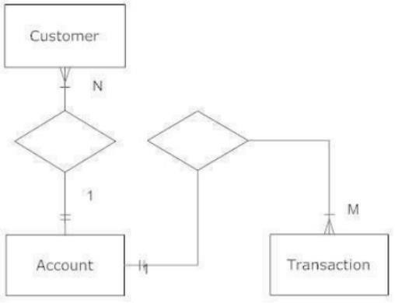
9 | P a g e
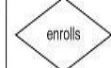
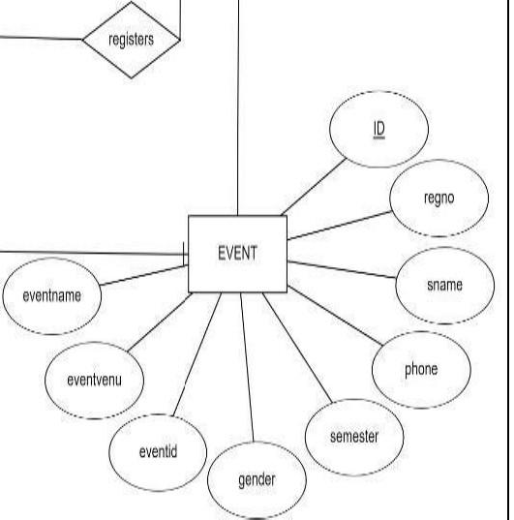
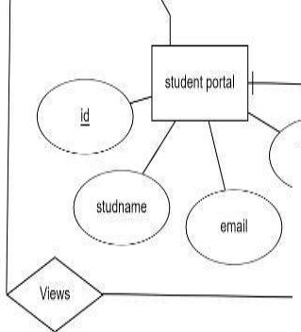
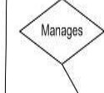
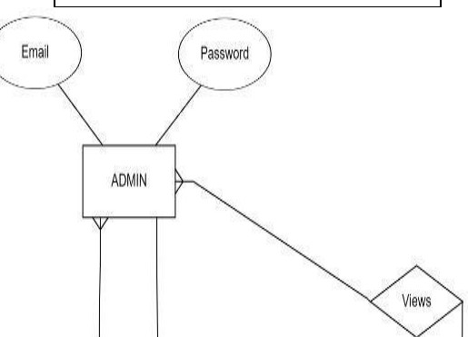
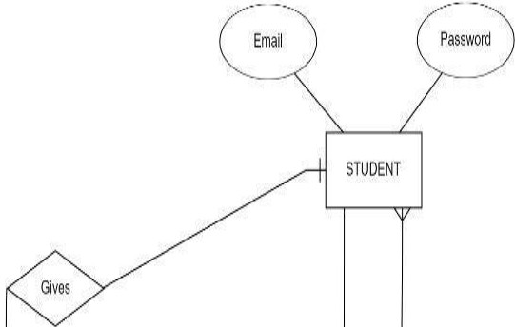
KRISTU JAYANTI COLLEGE(AUTONOMOUS) 20CS1K4237

ERDIAGRAM

..--...
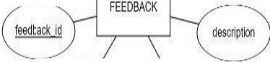

GG

.:.,)
·· ---·

10 I P a g e
KRISTU JAYANTI COLLEGE(AUTONOMOUS) 20CS1K4237

3.2 Data flow diagram (level 0 and level 1)

The Data Flow Diagrams (DFDs) are used for structure analysis and design. DFDs show the flow of data from external entities into the system. DFD also show how the data moves and is transformed from one process to another, as well as their logical storage.The
following symbols are used within DFDs.For clarity, a key has been provided at the bottom of this page.

A data flow diagram (DFD) is a graphical representation of the

"flow" of data through an information system, modeling its process aspects. A DFD is often used as a preliminary step to create an overview of the system, which can later be elaborated. DFDs can also be used for the visualization of data processing (structured design).
History:

Larry Constantine, the original developer of structured design, based on Martin and Estrin's "Data Flow Graph" model of computation. Starting in the 1970s, data flow diagrams (DFD) became a popular way to visualize the major steps and data involved in software system processes. DFDs were usually used to show data flow in a computer system, although they could in theory be applied to business process modeling. DFD were useful to document the major data flows or to explore a new high-level design in terms of data flow.
Theory:

Data flow diagram example

11 | P a g e
KRISTU JAYANTI COLLEGE(AUTONOMOUS) 20CS1K4237

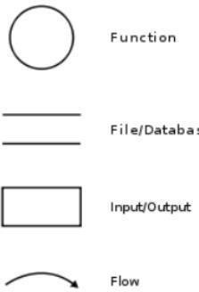

Data flow diagram - Yourdon/DeMarco notation

Data flow diagrams are also known as bubble charts. DFD is a designing tool used in the top-down approach to Systems Design. This context-level DFD is next "exploded", to produce a Level 1
DFD that shows some of the detail of the system being modeled. The Level 1 DFD shows how the system is divided into sub-systems (processes), each of which deals with one or more of the data flows to or from an external agent, and which together provide all of the functionality of the system as a whole. It also identifies internal data stores that must be present in order for the system to do
its job, and shows the flow of data between the various parts of the system.

12 | P a g e
KRISTU JAYANTI COLLEGE(AUTONOMOUS) 20CS1K4237

Data flow diagrams are one of the three essential perspectives of the structured- systems analysis and design method. The sponsor of a project and the end users will need to be briefed and consulted throughout all stages of a system's evolution. With a data flow diagram, users are able to visualize how the system will operate, what the system will accomplish, and how the system will be implemented. The old system's dataflow diagrams can be drawn up and compared with the new system's data flow diagrams to draw comparisons to implement a more efficient system. Data flow diagrams can be used to provide the end user with a physical idea of where the data they input ultimately has an effect upon the structure of the whole system from order to dispatch to report. How any system is developed can be determined through a data flow diagram model. In the course of developing a set of leveled data flow diagrams the analyst/designer is forced to address how the system may be decomposed into component sub-systems, and to identify the transaction data in the data model.Data flow diagrams can be used in both Analysis and Design phase of the SDLC.
There are different notations to draw data flow diagrams (Yourdon & Coad and

Gane&Sarson), defining different visual representations for processes, data stores, data flow, and external entities.

Physical vs. logical DFD

A logical DFD captures the data flows that are necessary for a system to operate. It describes the processes that are undertaken, the data required and produced
by each process, and the stores needed to hold the data. On the other hand, a physical DFD shows how the system is actually implemented, either at the moment (Current Physical DFD), or how the designer intends it to be in the future (Required Physical DFD). Thus, a Physical DFD may be used to describe the set of data items that appear on each piece of paper that move around an office, and the fact that a particular set of pieces of paper
are stored together in a filing cabinet. It is quite possible that a Physical

DFD will include references to data that are duplicated, or redundant, and that the data stores, if implemented as a set of database tables, would constitute an un-normalized (or denormalized) relational database. In contrast, a Logical DFD attempts to capture the data flow aspects of a system in a form that has neither redundancy nor duplication.
DATA FLOW SYMBOLS AND THERE MEANINGS:-

13 | P a g e
KRISTU JAYANTI COLLEGE(AUTONOMOUS) 20CS1K4237

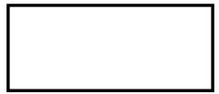

An entity a source of data or a destination for data.

Source/Sink: Represented by rectangles in the diagram. Sources and Sinks are external entities which are sources or destinations of data, respectively.
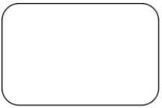

Process: Represented by circles in the diagram. Processes are responsible for manipulating the data. They take data as input and output an altered version of the data.

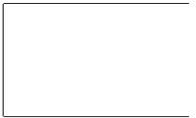

Data Store: Represented by a segmented rectangle with an open end on the right. Data Stores are both electronic and physical locations of data. Examples include databases, directories, files, and even filing cabinets and stacks of paper.

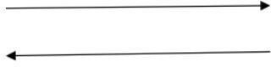

Data Flow: Represented by a unidirectional arrow. Data Flows show how data is moved through the System. Data Flows are labeled with a description of the data that is being passed through it.
A level-0 DFD is the most basic form of DFD. It aims to show how the entire system works at a glance. There is only one process in the system and all the data flows either into or
out of this process.Level-0 DFD’s demonstrates the interactions between the process and

external entities. They do not contain Data Stores.

14 | P a g e
KRISTU JAYANTI COLLEGE(AUTONOMOUS) 20CS1K4237

When drawing Level-0 DFD’s, we must first identify the process, all the external entities and all the data flows. We must also state any assumptions we make about the system. It is advised that we draw the process in the middle of the page. We then draw our external entities in the corners and finally connect our entities to our process with the data flows.
Below is an example of a Level-0 DFD.

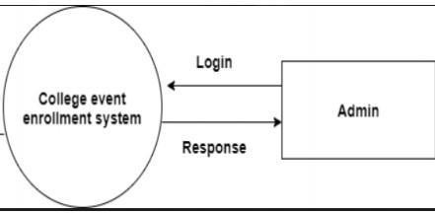

Level 1 DFD’s

Level 1 DFD’s aim to give an overview of the full system. They look at the system in more detail. Major processes are broken down into sub-processes. Level 1 DFD’s also identifies data stores that are used by the major processes.When constructing a Level 1 DFD, we must start by examining the Context Level DFD. We must break up the single process into its subprocesses. We must then pick out the data stores from the text we are given and include them in our DFD. Like the Context Level DFD’s, all entities, data stores and processes must be labeled. We must
also state any assumptions made from the text.

15 | P a g e
KRISTU JAYANTI COLLEGE(AUTONOMOUS) 20CS1K4237

LEVELl DFD

., LOGIN LOGIN
ADMIN 1

.\ ADD STUDENTS L
STUDENT

\ ADD EVENTS l
EVENT

'\ ENROLL EVENT L
ENROLLMENT

\ FEEDBACK /.
FEEDBACK

16 I P a g e

KRISTU JAYANTI COLLEGE(AUTONOMOUS) 20CS1K4237

3.3 GANTT CHART

A Gantt chart is a type of bar chart, devised by Henry Gantt in the 1910s, that illustrates a project schedule. Gantt charts illustrate the start and finish dates of the
terminal elements and summary elements of a project. Terminal elements and summary elements comprise the work breakdown structure of the project. Modern Gantt charts also show the dependency (i.e., precedence network) relationships between activities.
Gantt charts can be used to show current schedule status using percent-complete shadings and a vertical "TODAY" line as shown here. technique, Gantt charts were considered revolutionary when first introduced. This chart is also used in information technology to represent data that has been collected.
Historical Development:

The first known tool of this type was developed in 1896 by Karol Adamiecki, who called it a harmonogram. Adamiecki did not publish his chart until 1931, however, and only in Polish, which limited both its adoption and recognition of his authorship. The chart is named after Henry Gantt (1861– 1919), who designed his chart around the years 1910–1915.One of the first major applications of Gantt charts was by the United States during World War I, at the instigation of General William Crozier In the 1980s, personal computers allowed widespread creation of complex and elaborate Gantt charts. The first desktop applications were intended mainly for project managers and project schedulers. With the advent of the Internet and increased collaboration over networks at the end of the 1990s, Gantt charts became a common feature of web-based applications, including collaborative groupware.
GANTT CHART BENEFITS: Clarity:
One of the biggest benefits of a Gantt chart is the tool's ability to boil down multiple tasks and timelines into a single document. Stakeholders throughout an organization
can easily understand where teams are in a process while grasping the ways in which independent elements come together toward project completion.
Communication:

17 | P a g e
KRISTU JAYANTI COLLEGE(AUTONOMOUS) 20CS1K4237

Teams can use Gantt charts to replace meetings and enhance other status updates. Simply clarifying chart positions offers an easy, visual method to help
team members understand task progress.

Motivation:

Some teams or team members become more effective when faced with a form of external motivation. Gantt charts offer teams the ability to focus work at the front of a task timeline, or at the tail end of a chart segment. Both types of team members can find Gantt charts meaningful as they plug their own work habits into the overall project schedule.
Coordination:

For project managers and resource schedulers, the benefits of a Gantt chart include the ability to sequence events and reduce the potential for overburdening team members. Some project managers Creativity:
Sometimes, a lack of time or resources forces project managers and teams to find creative solutions. Seeing how individual tasks intertwine on Gantt charts
often encourages new partnerships and collaborations that might not have evolved under traditional task assignment systems.
Time Management:

Most managers regard scheduling as one of the major benefits of

Gantt charts in a creative environment. Helping teams understand the overall impact of project delays can foster stronger collaboration while encouraging better task organization.
Manageability:

For project managers handling complex assignments, like software publishing or event planning, the benefits of Gantt charts include externalizing assignments. By visualizing all of the pieces of a project puzzle, managers can make more focused, effective decisions about resources and timetables.
Efficiency:

18 | P a g e
KRISTU JAYANTI COLLEGE(AUTONOMOUS) 20CS1K4237

Another one of the benefits of Gantt charts is the ability for teams members to leverage each other’s deadlines for maximum efficiency. For instance, while one team member waits on the outcome of three other tasks before starting a crucial piece of the assignment, he or she can perform other project tasks. Visualizing resource usage
during projects allows managers to make better use of people, places, and things.

Accountability:

When project teams face major organizational change, documenting effort and outcomes becomes crucial to career success. Using Gantt charts during critical projects allows both project managers and participants to track team progress, highlighting both big wins and major failures.
During professional review periods, team members who

frequently exceed expectations can leverage this documentation into larger raises or bonuses.

Gantt Chart Importance:

The project's summary and terminal elements, which combine to form the project's internal structure, are shown on the Gantt chart. Many charts will also depict the precedence rankings and dependencies of various tasks within the project. The charts can illustrate the start and finish project terminal elements in project management. It can also show summary elements and terminal dependencies. The smallest task tracked as part of the project effort is known as a terminal element. Gantt chart represents the tasks in most modern project scheduling packages. However other management applications use simpler communication tools such as message boards, to- do lists and simple scheduling etc., therefore, they do not use Gantt charts as heavily.
The way to create this chart begins by determining and listing the necessary activities. Next, sketch out how you expect the chart to look. List which items depend on others and what activities take place when. For each activity, list how many man- hours it will require, and who is responsible. Lastly, determine the throughput time. This technique's primary advantage is its good graphical overview that is easy to understand for nearly all project participants and stakeholders. Its primary disadvantage is its limited applicability for many projects, since projects are often more complex
than can be effectively communicated with this chart.

19 | P a g e
KRISTU JAYANTI COLLEGE(AUTONOMOUS) 20CS1K4237

Here with is the Gantt chart for COllege Event Enrollment System

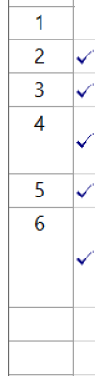
0 Task Name Resource Names Start Finish

../ | INITIATION PHASE  DEFINE PHASE | YASHASWI. SNEHA 3 days  YASHASWI. SNEHA 3 days | Tue 01-02-22 8:00AM  Fri 04-02-22 8:00AM | Thu 03-02-22 5:00 PM  Tue 08-02-22 5:00 PM
 | DESIGN PHASE | YASHASWI. SNEHA 10 days | Wed 09-02-22 8:00AM | Tue 22-02-22 5:00 PM
 | IMPLEMENTATION PHASE | YASHASWI. SNEHA 23 days | Tue 22-02-22 8:00AM | Thu 24-03-22 5:00 PM
 | TESTING PHASE | YASHASWI. SNEHA 2 days | Fri 25-03-22 8:00AM | Mon 28-03-22 5:00 PM
 | DEPLOYMENT AND | YASHASWI. SNEHA 5 days | Tue 29-03-22 8:00AM | Mon 04-04-22 5:00 PM
 | DOCUMENTATION PHASE

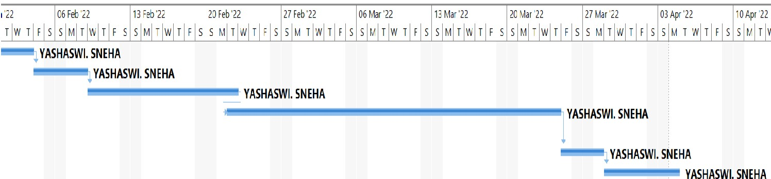

20 I P a g e
KRISTU JAYANTI COLLEGE(AUTONOMOUS) 20CS1K4237

3.4 INPUT/OUTPUT DESIGN LOGIN CODE:
Imports System.Data.SqlClient

Public Class LOGIN

Private Sub Button3_Click(sender As Object, e As EventArgs) Handles Button3.ClickREG_LOGIN.Show() Me.Hide()
End Sub

Private Sub Button1_Click(sender As Object, e As EventArgs) Handles Button1.ClickDim con As

SqlConnection = New SqlConnection("Data

Source=(LocalDB)\v11.0;AttachDbFilename=C:\Users\Yashaswi P\OneDrive\Desktop\eventreg\event reg

2012\event reg\event reg\Database1.mdf;Integrated Security=True") If con.State = ConnectionState.Open Then con.Close() con.Open()
Dim Cmd As New SqlCommand("select * from login where username='" & UCase(TextBox1.Text) & "' and password='" & TextBox2.Text & "'", con)

Dim D1 As SqlDataReader = Cmd.ExecuteReader()If

D1.HasRows Then main_page.Show() Me.Hide()

If con.State = ConnectionState.Open Then con.Close()Else

MsgBox("Username or Password is not correct please check")End If

21 | P a g e
KRISTU JAYANTI COLLEGE(AUTONOMOUS) 20CS1K4237

End Sub

Private Sub LOGIN_Load(sender As Object, e As EventArgs) Handles MyBase.LoadEnd Sub

End Class

Main Page CODE:

Public Class main_page

Private Sub Button2_Click(sender As Object, e As EventArgs) Handles Button2.Clickupdatee.Show() Me.Hide()

End Sub

Private Sub Button1_Click(sender As Object, e As EventArgs) Handles Button1.Clickeve.Show() Me.Hide()

End Sub

Private Sub Button3_Click(sender As Object, e As EventArgs) Handles Button3.ClickDELETE.Show() Me.Hide()
End Sub
Private Sub Button5_Click(sender As Object, e As EventArgs) Handles Button5.ClickLOGIN.Show() Me.Hide()

22 | P a g e
KRISTU JAYANTI COLLEGE(AUTONOMOUS) 20CS1K4237

End Sub

Private Sub Button4_Click(sender As Object, e As EventArgs) Handles Button4.Clickfeedback.Show() Me.Close()
End Sub

End Class

GRAPHIC DESIGN CODE:

Public Class GRAPHIC_DESIGN

Private Sub Button2_Click(sender As Object, e As EventArgs) Handles Button2.Clickeve.Show() Me.Hide()

End Sub

Private Sub Button1_Click(sender As Object, e As EventArgs) Handles Button1.Clickregistration.Show() Me.Hide()

End Sub

End Class

REGISTRATION FORM: CODE

Imports System.Data.SqlClientPublic

Class registration

Private Sub BindData()

Dim q As String = "Select* from feedback"

Using con As SqlConnection = New SqlConnection("Data

23 | P a g e
KRISTU JAYANTI COLLEGE(AUTONOMOUS) 20CS1K4237

Source=(LocalDB)\v11.0;AttachDbFilename=C:\Users\Yashaswi P\OneDrive\Desktop\eventreg\event reg

2012\event reg\event reg\Database1.mdf;Integrated Security=True")

Using cmd As SqlCommand = New SqlCommand(q, con)Using da As New SqlDataAdapter()
da.SelectCommand = cmd Using dt As New

DataTable() da.Fill(dt) DataGridView1.DataSource = dtEnd

Using

End Using

End Using

End Using

End Sub

Private Sub Button3_Click(sender As Object, e As EventArgs) Handles Button3.Clickmain_page.Show() Me.Close()

End Sub

Private Sub registration_Load(sender As Object, e As EventArgs) Handles MyBase.Load

'TODO: This line of code loads data into the 'Database1DataSet4.registration'table. You can move, or remove it, as needed.

Me.RegistrationTableAdapter.Fill(Me.Database1DataSet4.registration)End Sub

Private Sub Button1_Click(sender As Object, e As EventArgs) Handles Button1.Click

Dim con = connectdb()(0)

Dim cmd = connectdb()(1) Dim dr As SqlDataReader cmd.CommandType
= CommandType.Text cmd.CommandText = "select * from registration where regno='"& regno.Text & "' "

dr =

cmd.ExecuteReader

If dr.HasRows Then

MsgBox("successfully submited", MsgBoxStyle.Critical)

Else

24 | P a g e
KRISTU JAYANTI COLLEGE(AUTONOMOUS) 20CS1K4237

cmd = New SqlCommand("INSERT INTO registration values('" & regno.Text & "','" & sname.Text & "', '" & phone.Text & "', '" & semester.Text & "', '" & gender.Text &
"', '" & email.Text & "', '" & eventname.Text & "', '" & eventid.Text & "', '" &eventvenu.Text & "')", con)

If (regno.Text = "" And sname.Text = "" And phone.Text = "" And semester.Text

= "" And gender.Text = "" And email.Text = "" And eventname.Text = "" And eventid.Text ="" And eventvenu.Text = "") Then

MsgBox("Please enter the details") Else cmd.ExecuteNonQuery()
MsgBox("Successfully REGISTERED!", MsgBoxStyle.Information, "Success")BindData()

 | regno.Clear() | sname.Clear()
phone.Clear()  email.Clear() | semester.Clear()  eventname.Clear() | gender.Clear()  eventid.Clear()

eventvenu.Clear() End If
End If

End Sub

Private Sub Button4_Click(sender As Object, e As EventArgs)End Sub

Private Sub Button4_Click_1(sender As Object, e As EventArgs)End Sub

Private Sub load_Click(sender As Object, e As EventArgs) Handles load.ClickDim code As Date code = Now eventid.Text = Format(code,

"mmddhhss").ToString

End Sub

UPDATE FORM CODE

Imports System.Data.SqlClientPublic

Class updatee

Private Sub Button2_Click(sender As Object, e As EventArgs) Handles Button2.Clickmain_page.Show()

25 | P a g e
KRISTU JAYANTI COLLEGE(AUTONOMOUS) 20CS1K4237

Me.Hide() End Sub
Private Sub Button1_Click(sender As Object, e As EventArgs) Handles Button1.ClickDim con As New

SqlConnection

Dim cmd As New SqlCommand

Dim dr As SqlDataReader

con.ConnectionString = "Data Source=(LocalDB)\v11.0;AttachDbFilename=C:\Users\Yashaswi P\OneDrive\Desktop\eventreg\event reg 2012\event reg\event reg\Database1.mdf;Integrated Security=True" con.Open()
cmd = New SqlCommand("SELECT * FROM registration where regno ='" + studid.Text +"' ", con)

dr = cmd.ExecuteReader If dr.Read Then studid.Text = dr.GetValue(0) studname.Text = dr.GetValue(1) email.Text = dr.GetValue(2)
Else

MessageBox.Show("no record found")End If

End Sub

Private Sub Button3_Click(sender As Object, e As EventArgs) Handles Button3.ClickDim con As New

SqlConnection

Dim cmd As New SqlCommand

con.ConnectionString = "Data Source=(LocalDB)\v11.0;AttachDbFilename=C:\Users\Yashaswi P\OneDrive\Desktop\eventreg\event reg 2012\event reg\event reg\Database1.mdf;Integrated Security=True" con.Open()
If (studname.Text = "" And email.Text = "") Then

Else
MessageBox.Show("Please enter the details")

cmd = New SqlCommand("UPDATE registration set sname ='" & studname.Text & "',

email = '" & email.Text & "' WHERE regno='" & studid.Text & "' ", con)

cmd.ExecuteNonQuery()

26 | P a g e

KRISTU JAYANTI COLLEGE(AUTONOMOUS) 20CS1K4237

"succeed") studname.Clear() email.Clear()
End If

End Sub

End Class
MsgBox("student data updated successfully", MsgBoxStyle.Information,

FEEDBACK CODE:

Imports System.Data.SqlClientPublic

Class feedback

Private Sub BindData()

Dim q As String = "Select* from feedback"

Using con As SqlConnection = New SqlConnection("Data

Source=(LocalDB)\v11.0;AttachDbFilename=C:\Users\Yashaswi P\OneDrive\Desktop\eventreg\event reg

2012\event reg\event reg\Database1.mdf;Integrated Security=True")

Using cmd As SqlCommand = New SqlCommand(q, con)Using da As New SqlDataAdapter()
da.SelectCommand = cmd Using dt As New

DataTable() da.Fill(dt) DataGridView1.DataSource = dtEnd

Using

End Using

End Using

End Using

End Sub

Private Sub feedback_Load(sender As Object, e As EventArgs) Handles MyBase.Load

27 | P a g e

KRISTU JAYANTI COLLEGE(AUTONOMOUS) 20CS1K4237

'TODO: This line of code loads data into the 'Database1DataSet3.FEEDBACK' table. You can move, or remove it, as needed.

Me.FEEDBACKTableAdapter.Fill(Me.Database1DataSet3.FEEDBACK)End

Sub

Private Sub Button2_Click(sender As Object, e As EventArgs) Handles Button2.Clickmain_page.Show() Me.Hide()

End Sub

Private Sub Button1_Click(sender As Object, e As EventArgs) Handles Button1.ClickDim con =

connectdb()(0) Dim cmd = connectdb()(1)
cmd = New SqlCommand("INSERT INTO FEEDBACK values('" & FNAME.Text & "', '" & REGNO.Text & "', '" & FEEDBACKK.Text & "')", con)

If (FNAME.Text = "" And REGNO.Text = "" And FEEDBACKK.Text = "") Then

MsgBox("Please enter the details") Else cmd.ExecuteNonQuery()
MsgBox("Successfully SUBMITTED!", MsgBoxStyle.Information, "Success")

binddata()

FNAME.Clear() REGNO.Clear() FEEDBACKK.Clear()
End If

End Sub

End Class

28 | P a g e

KRISTU JAYANTI COLLEGE(AUTONOMOUS) 20CS1K4237

4. SYSTEM CONFIGURATION

4.1 HARDWARE REQUIREMENTS

DESKTOP/LAPTOP : LAPTOP PROCESSOR : RYZEN 5
RAM : 8GB

SYSTEM TYPE :WIN10HARD DISK : 1TB+256 SSD

OTHERS : WIRED KEYBOARD AND MOUSE (BLUETOOTH)

4.2 SOFTWARE REQUIREMENTS

OPERATING SYSTEM : MICROSOFT WINDOW10 PROFFESSION FRONTEND : VB.NET 2012
BACKEND : SQL SERVER 2012

TOOL (S) : MICROSOFT PROJECT PLANNER2013

DOCUMENTATION : MICROSOFT WORD 2010

29 | P a g e
KRISTU JAYANTI COLLEGE(AUTONOMOUS) 20CS1K4237

5. DETAILS OF SOFTWARE

5.1 OVERVIEW OF FRONT-END

MICROSOFT VISUAL STUDIO 2012:

Visual Studio supports different programming languages and allows the code editor and debugger to support nearly any programming language, provided a language-specific service exists. Built-in languages include C, C++, Visual C++ and VB.NET. Support for other languages such as Python, Ruby, Node.js, and M among others is available via language services installed separately. It also supports XML/XSLT, HTML/XHTML, JavaScript and CSS. Java (and J#) were supported in the past.

Microsoft provides a free version of Visual Studio called the Community edition that supports plugins and is available at no cost for all users. Support for programming languages is added by using a specific VSPackage called a Language Service. A language service defines various interfaces which the VSPackage implementation can implement to add support for various functionalities. Functionalities that can be added this way include syntax coloring, statement completion, brace matching, parameter information tooltips, member lists and error markers for background compilation. If the interface is implemented, the functionality will be available for the language. Language services are implemented on a per- language basis. The implementations can reuse code from the parser or the compiler for the language. Language services can be implemented either in native code or managed code. For native code, either the native COM interfaces or the Babel Framework can be used. For managed code, the MPF includes wrappers for writing managed language services.

Features

Boolean Conditions

• Automatic Garbage Collection

30 | P a g e
KRISTU JAYANTI COLLEGE(AUTONOMOUS) 20CS1K4237

• Standard Library Assembly Versioning

• Properties and Events

• Delegates and Events Management

• Easy-to-use Generics

• Indexers

• Conditional Compilation

Advantages
• Simple Multithreading

The structure of the Basic programming language is very simple, particularly as to the executable code.
1. VB is not only a language but primarily an integrated, interactive development environment (“IDE“).
2. The VB-IDE has been highly optimized to support rapid application development (“RAD”). It is particularly easy to develop graphical user interfaces and to connect them to handler functions provided by the application.
3. The graphical user interface of the VB-IDE provides intuitively appealing views for the management of the program structure in the large and the various types of entities (classes, modules, procedures, forms …)
4. VB provides a comprehensive interactive and context-sensitive online

help system.

31 | P a g e

KRISTU JAYANTI COLLEGE(AUTONOMOUS) 20CS1K4237

5. When editing program texts the “IntelliSense” technology informs you in a little popup window about the types of constructs that may be entered at the current cursor location.
6. VB is a component integration language which is attuned to Microsoft’s

Component Object Model (“COM”).

7. COM components can be written in different languages and then integrated using VB.

8. Interfaces of COM components can be easily called remotely via Distributed COM (“DCOM”), which makes it easy to construct distributedapplications.
9. COM components can be embedded in / linked to your application’s user interface and also in/to stored documents (Object Linking and Embedding “OLE”, “Compound Documents”).
10. There is a wealth of readily available COM components for many different purposes.

11. Visual Basic is built around the .NET environment used by all Microsoft Visual languages, so there is very little that can’t be done in Visual Basic that can be done in other languages (such as C#).
Disadvantages

1. Visual basic is a proprietary programming language written by Microsoft, so programs written in Visual basic cannot, easily, be transferred to other operating systems.
2. There are some, fairly minor disadvantages compared with C. C has better declaration of arrays – its possible to initialise an array of structures in C at declaration time; this is impossible in VB
5.2OVERVIEW OF BACK-END

Microsoft SQL Server 2012:

32 | P a g e
KRISTU JAYANTI COLLEGE(AUTONOMOUS) 20CS1K4237

Microsoft SQL Server is a relational database management system developed by

Microsoft. As a database server, it is a software product with the primary function of storing and retrieving data as requested by other software applications—which may run either on the same computer or on another computer across a network (including the Internet). Microsoft markets at least a dozen different editions of Microsoft SQL Server, aimed at different audiences and for workloads ranging from small single-machine applications to large Internet- facing applications with many concurrent users. The protocol layer implements the external interface to SQL Server. All operations that can be invoked on SQL Server are communicated to it via a Microsoft-defined format, called Tabular Data Stream (TDS). TDS is an application layer protocol, used to transfer data between a database server and a client. Initially designed and developed by Sybase Inc. for their Sybase SQL Server relational database engine in 1984, and later by Microsoft in Microsoft SQL Server, TDS packets can be encased in other physical transport dependent protocols, including TCP/IP, named pipes, and shared memory. Consequently, access to SQL Server is available over these protocols. In addition, the SQL Server API is also exposed over web services.
A Relational Database Management System (RDBMS) is software that:

• Enables you to implement a database with tables, columns and indexes.

• Guarantees the Referential Integrity between rows of various tables.

• Updates the indexes automatically.

• Interprets an SQL query and combines information from various tables. MySQL is a leading open source database management system. It is a multi-user, multithreaded database management system. MySQL is especially popular on the web. It is one of the parts of the very popular LAMP platform. Linux, Apache, MySQL and PHP.
MySQL database is available on most important OS platforms. It runs on BSD Unix, Linux, Windows or Mac. Wikipedia, YouTube, Facebook use MySQL. These sites manage millions of queries each day. MySQL comes in two
versions: MySQL server system and MySQL embedded system. The MySQL server software and the client libraries are dual-licensed: GPL version 2 and proprietary license.
MySQL is a fast, easy-to-use RDBMS being used for many small and big businesses.

33 | P a g e
KRISTU JAYANTI COLLEGE(AUTONOMOUS) 20CS1K4237

MySQL is developed, marketed, and supported by MySQL AB, which is a Swedish company.

Advantages:-

MySQL is becoming so popular because of many good reasons:

• MySQL is released under

an open-source license. So you have nothing to pay to use it.
• MySQL is a very powerful program in its own right. It handles a large subset of the functionality of the most expensive and powerful database packages.
MySQL uses a standard form of the well-known SQL data language.


• MySQL works on many operating systems and with many languages including PHP, PERL, C, C++, JAVA, etc.
• MySQL works very quickly and works well even with large data sets.

• MySQL is very friendly to PHP, the most appreciated language for web development. MySQL supports large databases, up to 50 million

rows or more in a table. The default file size limit for a table is 4GB, but you can

increase this (if your operating system can handle it) to a theoretical limit of 8 million terabytes

(TB).

• MySQL is customizable. The open-source GPL license allows programmers to modify the

MySQL software to fit their own specific environments.

Features

Internals and portability

• Written in C and C++.

• Tested with a broad range of different compilers.

• Works on many different platforms. .
• For portability, uses CMake in MySQL 5.5 and up. Previous series use GNU Automake, Autoconf, and Libtool.

34 | P a g e
KRISTU JAYANTI COLLEGE(AUTONOMOUS) 20CS1K4237

• Tested with Purify (a commercial memory leakage detector) as well as with Valgrind, a GPL

tool.

• Uses multi-layered server design with independent modules.

• Designed to be fully multi-threaded using kernel threads, to easily use multiple CPUs if they are available.
• Provides transactional and non transactional storage engine

35 | P a g e
KRISTU JAYANTI COLLEGE(AUTONOMOUS) 20CS1K4237

DATA TYPES

FLOAT, DOUBLE, CHAR, VARCHAR, BINARY, VARBINARY,
TEXT, BLOB, DATE,

TIME,DATETIME, TIMESTAMP, YEAR, SET, ENUM, and Open GIS spatial types.

• Fixed-length and variable-length string types.

Statements and Functions

• Full operator and function support in the SELECT list and WHERE clause of queries. For example: Mysql> SELECT CONCAT (first_name, ' ', last_name)
->WHincome/dependents > 10000 AND age > 30;Full support for SQL GROUP BY and

ORDERBY clauses.function(COUNT(), AVG(), STD(), SUM(), MAX(), MIN(),andGROUP_CONCAT()).

• Support for LEFT OUTER JOIN and RIGHT OUTER JOIN with both standard SQL and ODBC

syntax.

• Support for aliases on tables and columns as required by standard SQL.

• Support for DELETE, INSERT, REPLACE, and UPDATE to return the number of

rows that were changed (affected), or to return the number of rows matched instead by setting a flag when connecting to the server.

• Support for MySQL-specific SHOW statements that retrieve information about databases, storage engines, tables, and indexes. Support for theINFORMATION_SCHEMA database, implemented according to standard SQL.
• An EXPLAIN statement to show how the optimizer resolves a query.

• Independence of function names from table or column names. For example, ABS is a valid column name. The only restriction is that for a function call, no spaces are permitted between the function name and the “(” that follows it.

• You can refer to tables from different databases in the same statement.

36 | P a g e

KRISTU JAYANTI COLLEGE(AUTONOMOUS) 20CS1K4237
Security

• A privilege and password system that is very flexible and secure, and that enables host- based verification.
• Password security by encryption of all password traffic when you connect to a server.

Scalability and Limits

• Support for large databases. We use MySQL Server with databases that contain 50 million records. We also know of users who use MySQL Server with 200,000 tables and about 5,000,000,000 rows.
• Support for up to 64 indexes per table. Each index may consist of 1 to 16 columns or parts of columns. The maximum index width for InnoDB tables is either 767 bytes or
3072 bytes. The maximum index width for MyISAM tables is 1000 bytes. An index may

use a prefix of a column for CHAR, VARCHAR, BLOB, or TEXT column types.

Connectivity

• Clients can connect to MySQL Server using several protocols:

• Clients can connect using TCP/IP sockets on any platform.

• On Windows systems, clients can connect using named pipes if the server is started with the --enable-named-pipe option. Windows servers also support shared- memory connections if started with the --shared-memory option. Clients can connect through shared memory by using the--protocol=memory option.
• On UNIX systems, clients can connect using Unix domain socket files.

• MySQL client programs can be written in many languages. A client library written in C is available for clients written in C or C++, or for any language that provides C bindings.APIs for C, C++, Eiffel, Java, Perl, PHP, Python, Ruby, and Tcl are available, enabling MySQL clients to be written in many languages..
The Connector/ODBC (MyODBC) interface provides MySQL support for client programs that use ODBC (Open Database Connectivity) connections. For example, you can use MS Access to connect to your MySQL server. Clients can be run on Windows or Unix. Connector/ODBC source is available. All ODBC 2.5 functions are supported, as are many others.The Connector/J interface provides MySQL support for Java client programs that use JDBC connections. Clients can be run on Windows or Unix. Connector/J source is

37 | P a g e

KRISTU JAYANTI COLLEGE(AUTONOMOUS) 20CS1K4237
available..MySQL Connector/Net enables developers to easily create NET applications that require secure, high-performance data connectivity with MySQL. It implements the required ADO.NET interfaces and integrates into ADO.NET aware tools. Developers can build applications using their choice of .NET languages. MySQL Connector/Net is a fully managed ADO.NET driver written in 100% pure C#.
Localization

• The server can provide error messages to clients in many languages.

• Full support for several different character sets, including latin1 (cp1252), german, big5, ujis, several Unicode character sets, and more. For example, the Scandinavian characters “å”, “ä” and “ö” are permitted in table and column names.
• All data is saved in the chosen character set.

• Sorting and comparisons are done according to the chosen character set and collation

(using latin1 and Swedish collation by default). It is possible to change this when the MySQL server is started. To see an example of very advanced sorting, look at the Czech sorting code. MySQL Server supports many different character sets that can be specified at compile time and runtime.
• The server time zone can be changed dynamically, and individual clients can specify their own time zone.
Clients and Tools

• MySQL includes several client and utility programs. These include both command-line programs and graphical programs.
• MySQL Server has built-in support for SQL statements to check, optimize, and repair tables. These statements are available from the command line through themysqlcheck client. MySQL also includesmyisamuch, a very fast command-line utility for performing
these operations on MyISAM tables..

• MySQL programs can be invoked with the --help or -? Option to obtain online

5.2 ABOUT THE PLATFORM

Windows is a series of Operating Systems developed by Microsoft. Each version Windows includes a Graphical User Interface, with a desktop that allows users to view files and folders in Windows. For the past two decades, Windows has been the most widely used operating

38 | P a g e

KRISTU JAYANTI COLLEGE(AUTONOMOUS) 20CS1K4237
system for personal computers PCs. Microsoft Windows is designed for both home computing and professional purposes. Past versions of Windows home editions include Windows 3.0 (1990), Windows 3.1 (1992), Windows 95 (1995), Windows 98 (1998), Windows Me (2000), Windows XP (2001), and Windows Vista (2006). The current version, Windows 7, was released in 2009. The first business-oriented version of Windows, called Windows NT 3.1, was in 1993. This was followed by Windows 3.5, 4.0, and Windows 2000. When Microsoft released Windows XP in 2001, the company simply created different editions of the operating system for personal and business purposes. Windows Vista and Windows 7 have followed the same release strategy.Windows is designed to run on standard x86 hardware, such as Intel and AMD processors. Therefore, it can be installed on multiple brands of hardware, such as Dell, HP, and Sony computers, as well as home-built PCs. Windows 7 also includes several touchscreen features, that allow the operating system to run on certain tablets and computers with touchscreen displays. Microsoft's mobile operating system, Windows Phone, is designed specifically for smartphones and runs on several brands of phones, including HTC, Nokia, and Samsung.

.NET FRAMEWORK

.NET Framework (pronounced as "dot net") is a software framework developed by Microsoft that runs primarily on Microsoft Windows. It includes a large class library named Framework Class Library (FCL) and provides language interoperability (each language can use code written in other languages) across several programming languages. Programs written for .NET Framework execute in a software environment (in contrast to a hardware environment) named Common Language Runtime (CLR), an application virtual machine that provides services such as security, memory management, and exception handling. As such, computer code written using
.NET Framework is called "managed code". FCL and CLR together constitute the

.NET Framework. FCL provides user interface, data access, database connectivity, cryptography, web application development, numeric algorithms, and network communications. Programmers produce software by combining their source code with
.NET Framework and other libraries. The framework is intended to be used by newest applications created for the Windows platform. Microsoft also produces an integrated development environment largely for .NET software called Visual Studio. .NET Framework began as proprietary software, although the firm worked to standardize the

39 | P a g e

KRISTU JAYANTI COLLEGE(AUTONOMOUS) 20CS1K4237
software stack almost immediately, even before its first release. Despite the standardization efforts, developers, mainly those in the free and open- source software communities, expressed their unease with the selected terms and the prospects of any free and open-source implementation, especially regarding software patents. Sinc then, Microsoft has changed .NET development to more closely follow a contemporary model of a communitydeveloped software project, including issuing an update to its patent promising to address the concerns.
6. TESTING

Testing is a vital part of software development, and it is important to start it as early as possible, and to make testing a part of the process of deciding requirements. To get the most useful perspective on your development project, it is worthwhile devoting some thought to the entire lifecycle including how feedback from users will influence the future of the application. The tools and techniques we've discussed in this book should help your team to be more responsive to changes without extra cost, despite the necessarily wide variety of different development processes. Nevertheless, new tools and process improvements should be adopted gradually, assessing the results after each step.
Testing is part of a lifecycle. The software development lifecycle is one in which you hear of a need, you write some code to fulfil it, and then you check to see whether you have pleased the stakeholders—the users, owners,
and other people who have an interest in what the software does. Hopefully they like it, but would also like some additions or changes, so you update or augment your code; and so the cycle continues. This cycle might happen every few days, as it does in Fabrikam's ice cream vending project, or every few years, as it does in Contoso's carefully specified and tested healthcare support system. Software development lifecycle Testing is a proxy for the customer.

You could conceivably do your testing by releasing it into the wild and waiting for the complaints and compliments to come back. Some companies have been accused of having such a strategy as their business model even before it became fashionable. But on the whole, the books are better balanced by trying to make sure that the software will satisfy the customer before we hand it over. We therefore design tests based on the stakeholders' needs, and run the tests before the product reaches the users. Preferably well before then, so as not to waste our time working on something that isn't going to do the job.

40 | P a g e

KRISTU JAYANTI COLLEGE(AUTONOMOUS) 20CS1K4237
In this light, two important principles become clear:

• Tests represent requirements.

Whether you write user stories on sticky notes on the

wall, or use cases in a big thick document, your tests should be derived from andlinked to those requirements. And as we've said, devising tests is a good vehicle for discussing the requirements.

• We're not done till the tests pass.

The only useful measure of completion is when tests have been performed successfully. Those principles apply no matter how you develop your software.
Software Testing Types:

Black box testing – Internal system design is not considered in this type of testing. Tests are based on requirements and functionality. White box testing – This testing is based on knowledge of the internal logic of an application’s code. Also known as Glass box Testing. Internal software and code working
should be known for this type of testing. Tests are based on coverage of code statements, branches, paths, conditions.
Unit testing – Testing of individual software components or modules.Typically done by the programmer and not by testers, as it requires detailed knowledge of the internal program design and code.may require developing test driver modules or test harnesses.
Incremental integration testing – Bottom up approach for testing i.e continuous testing of an application as new functionality is added; Application functionality and modules should be independent enough to test separately. done by programmers or by testers.
Integration testing – Testing of integrated modules to verify combined functionality after integration. Modules are typically code modules, individual applications, client and server applications on a network, etc. This type of testing is especially relevant to client/server and distributed systems.
Functional testing – This type of testing ignores the internal parts and focus on the output is as per requirement or not. Black-box type testing geared to functional requirements of an application.
System testing – Entire system

41 | P a g e

KRISTU JAYANTI COLLEGE(AUTONOMOUS) 20CS1K4237
is tested as per the requirements. Black-box type testing that

is based on overall requirements specifications, covers all combined parts of a system

End-to-end testing – Similar to system testing, involves testing of a complete application environment in a situation that mimics real-world use, such as interacting with a database, using network communications, or interacting with other hardware, applications, or systems if appropriate.
Sanity testing – Testing to determine if a new software version is performing well enough to accept it for a major testing effort. If application is crashing for initial use then system is not stable enough for further testing and build or application is assigned to fix.

Regression testing – Testing the application as a whole for the modification in any module or functionality. Difficult to cover all the system in regression testing so typically automation tools are used for these testing types.
Acceptance testing -Normally this type of testing is done to verify if system meets the customer specified requirements. User or customers do this testing to determine whether to accept application.

Load testing – It’s a performance testing to check system behavior under load. Testing an application under heavy loads, such as testing of a web site under a range of loads to determine at what point the system’s response time degrades or fails.
Stress testing – System is stressed beyond its specifications to check how and when it fails. Performed under heavy load like putting large number beyond storage capacity, complex database queries, continuous input to system or database load.
Performance testing – Term often used interchangeably with ‘stress’ and ‘load’ testing. To check whether system meets performance requirements. Used different performance and load tools to do this.
Usability testing – User-friendliness check. Application flow is tested, Can new user understand the application easily, Proper help documented whenever user stuck at any point.

Basically system navigation is checked in this testing.

Install/uninstall testing –

42 | P a g e

KRISTU JAYANTI COLLEGE(AUTONOMOUS) 20CS1K4237

Tested for full, partial, or upgrade install/uninstall processes on different operating systems under different hardware, software environment.
Recovery testing – Testing how well a system recovers from crashes, hardware failures, or other catastrophic problems.
Security testing – Can system be penetrated by any hacking way. Testing how well the system protects against unauthorized internal or external access. Checked if system, database is safe from external attacks.
Compatibility testing –

Testing how well software performs in a particular hardware/software/operating system/network environment and different combination s of above.

Comparison testing – Comparison of product strengths and weaknesses with previous versions or other similar products.

Alpha testing – In house virtual user environment can be created for this type of testing. Testing is done at the end of development. Still minor design changes may be made as a result of such testing.

Beta testing – Testing typically done by end-users or others. Final testing before releasing application for commercial purpose
7. CONCLUSION AND FUTURE ENHANCEMENT CONCLUSION

The main objective of College Event Enrollment System is to automate the manual registration process through online. It can manage all the details of different kinds of events and provides up-to-date information of the events, which will assist the students with necessary information about the events. The main purpose of the project is to build an application system to reduce the manual work.

FUTURE ENHANCEMENT

Our site is helpful for both the admin as well as the students .The event enrollment is a platform where multiple Event registration can be done is a singe platform,making managements and registration easy,All the Event information will give during the
registration.

43 | P a g e
KRISTU JAYANTI COLLEGE(AUTONOMOUS) 20CS1K4237

8. BIBLIOGRAPHY

Web References:-

⚫ www.wikipedia.comhttps

⚫ www.youtube.com

⚫ www.tutorialspoint.com

⚫ www.wikipedia.com

⚫ www.youtube.com

⚫ www.tutorialspoint.com

44 | P a g e
KRISTU JAYANTI COLLEGE 20CS1K4237

LOGIN
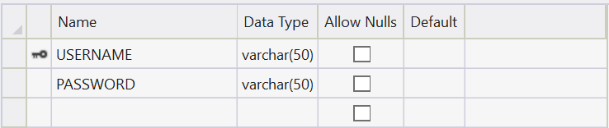

REGISTRATION
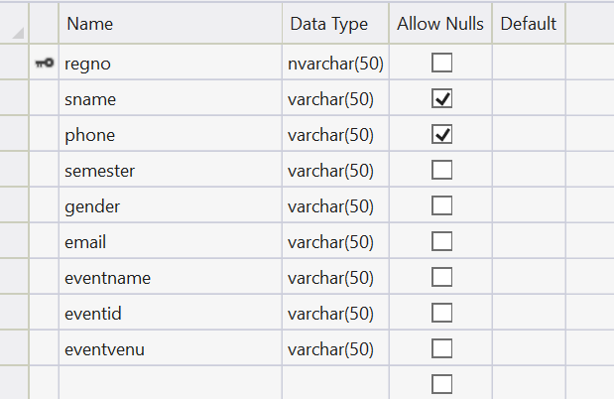

EVENT ENROLLMENT
APPENDICES A-Table Structure

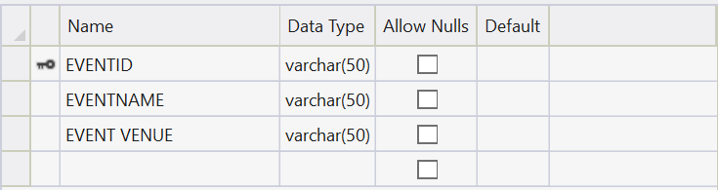

45 | P a g e

KRISTU JAYANTI COLLEGE 20CS1K4237

UPDATE

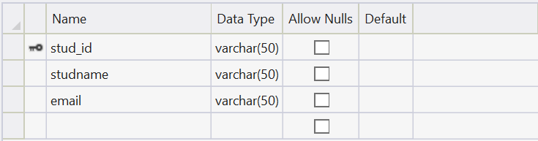

FEEDBACK

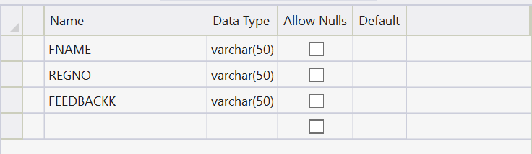

46 | P a g e
KRISTU JAYANTI COLLEGE 20CS1K4237

APPENDICES B-Screenshots

LOGIN PAGE

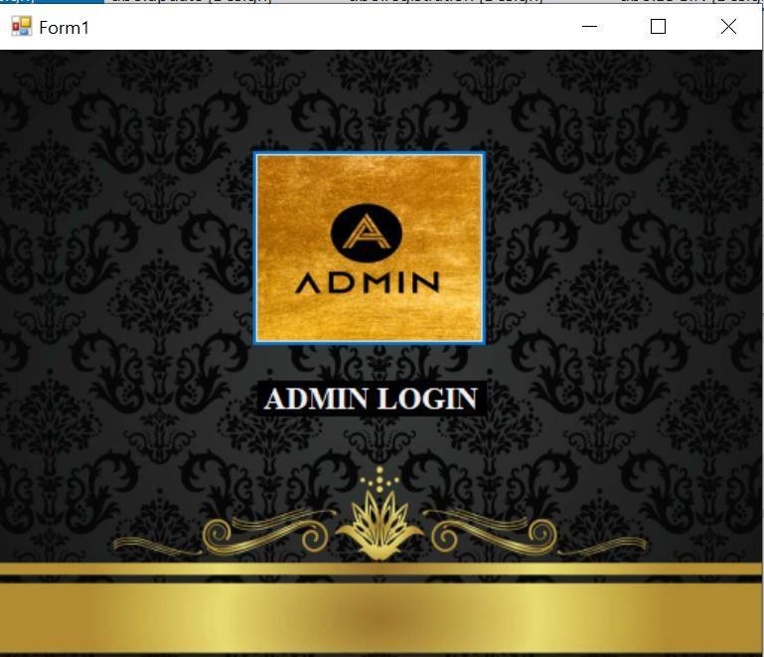

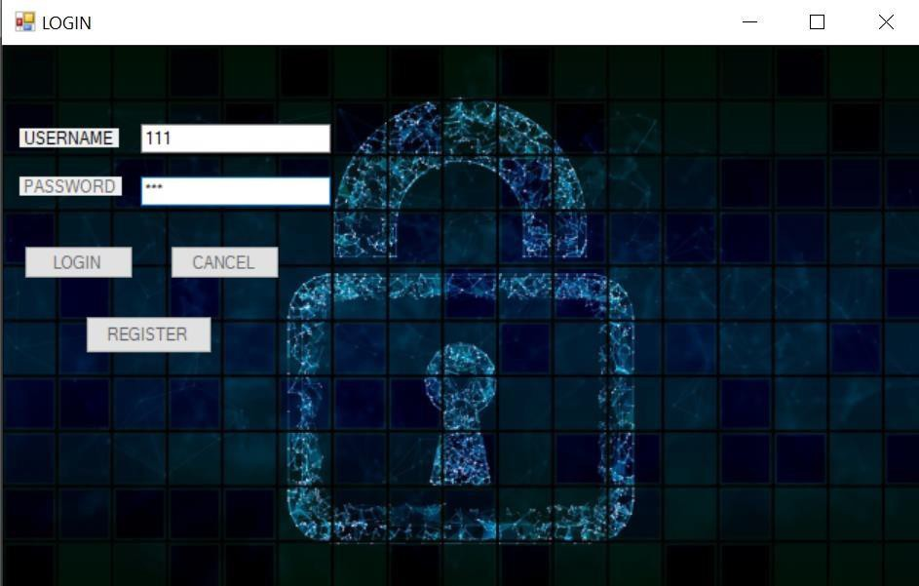

47 | P a g e
KRISTU JAYANTI COLLEGE 20CS1K4237

MAIN PAGE

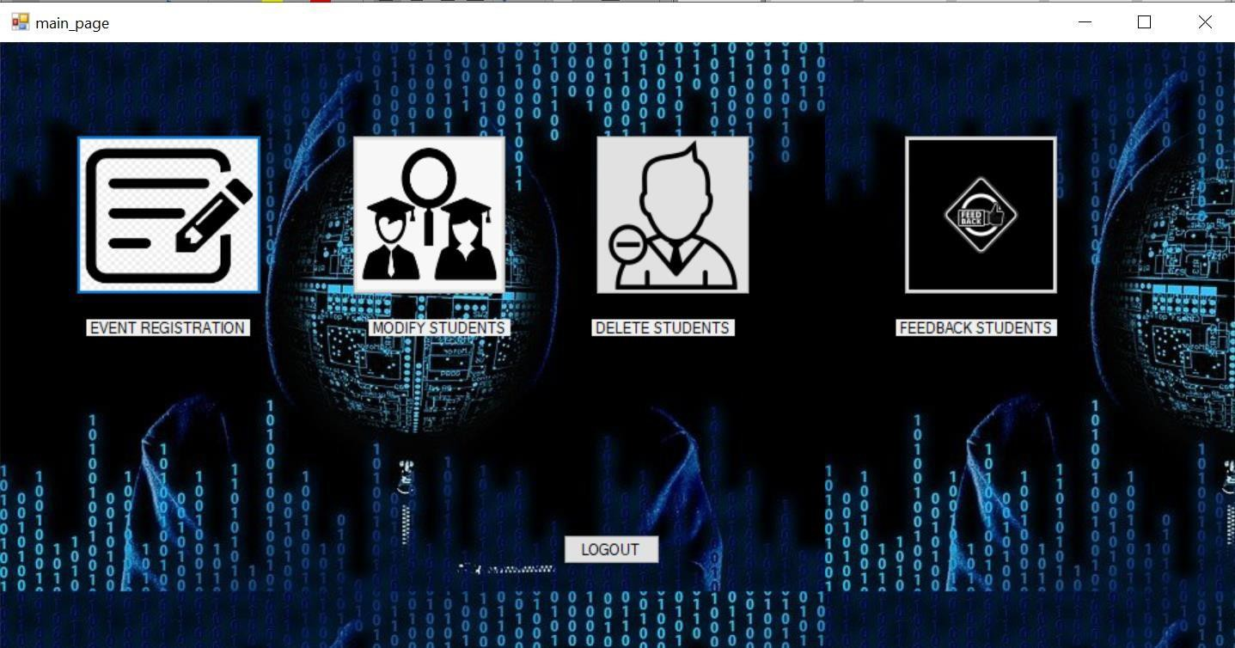

EVENT REGISTRATION

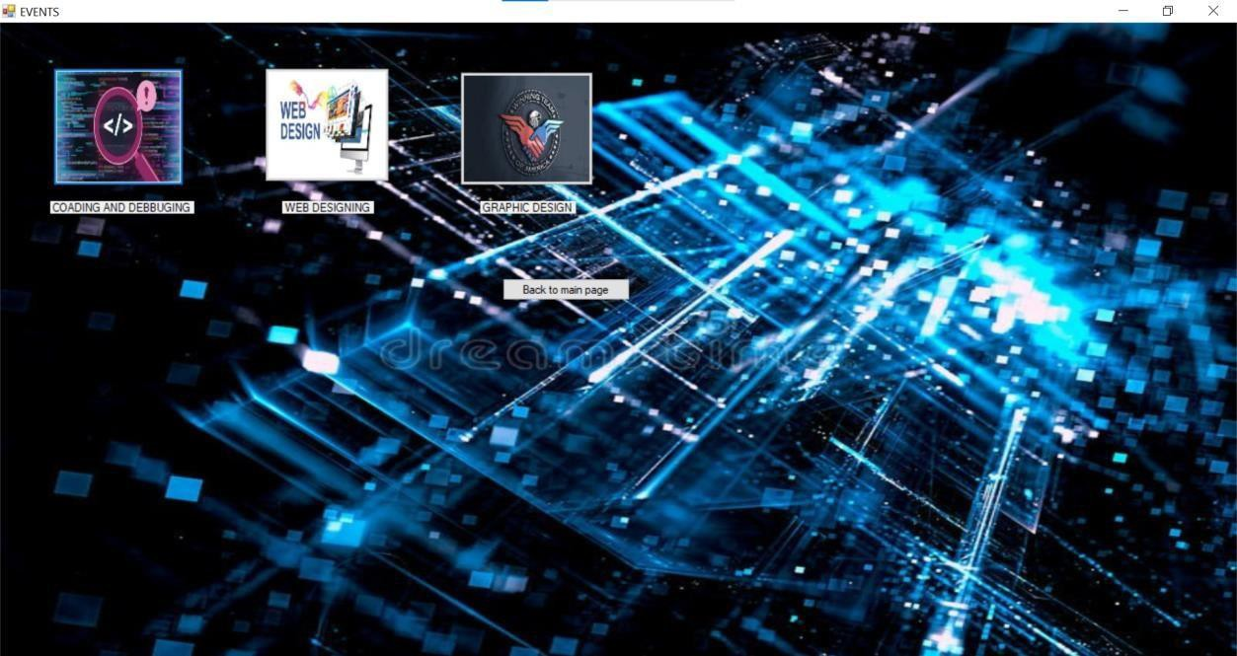

48 | P a g e
KRISTU JAYANTI COLLEGE 20CS1K4237

UPDATE STUDENT

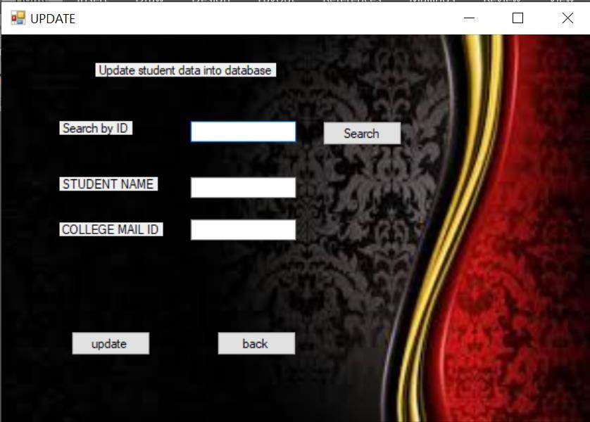

MODIFY STUDENT

49 | P a g e

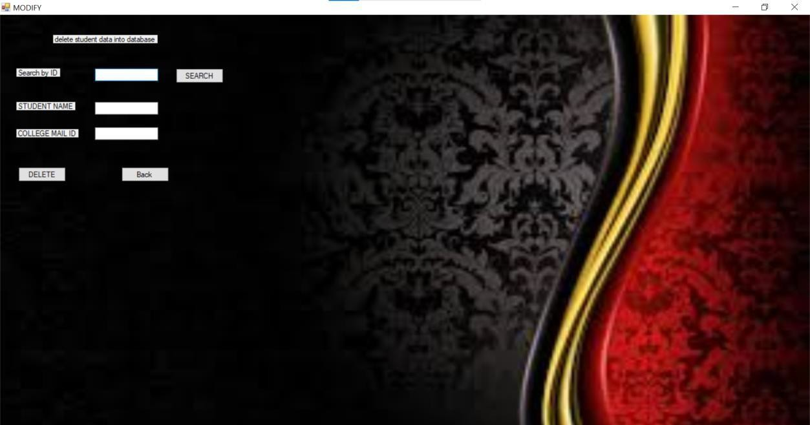

FEEDBACK

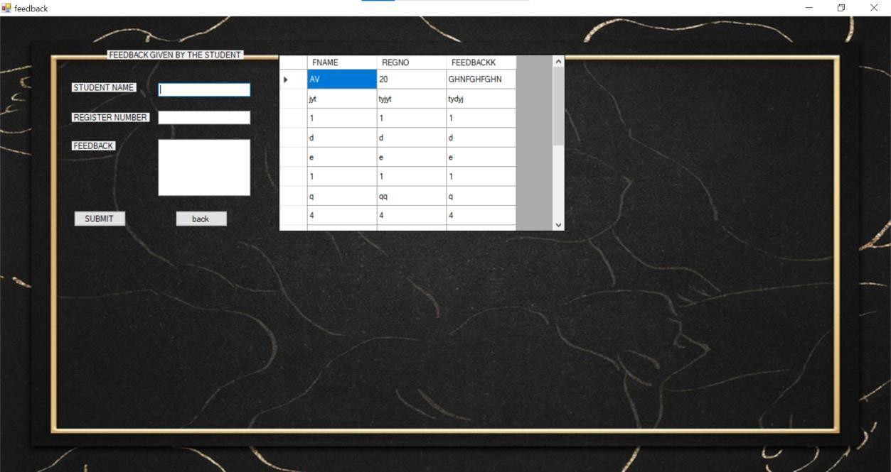

50 | P a g e

APPENDICES C-Sample Report of test cases

SL.NO | Test case-id | Test description | Steps to execute | Test data | Expected res uJt | A tcu al resuJt | Status
I | Case ) | Regista rti on for m phone numbe r checking | Type phone number | 9974632232 | Phone number val id | Phone  n umber va lid | Pass
2 | Case2 | Regista rti on for m phone number checking | Type phone number | 9938747812  347 | Pho ne number invalid | P hone number inva lid | Fa il
3 | Case3 | Regista rtion form ema il checking | Type  Ema il-ill | 1 1 2@kjc.co m | Ema i l-iD  valid | E mai l-iD  va lid | pass
4 | Case4 | Regista rti on form ema il checking | Type  Ema i l-ill | 1 1 2kjc.com | Ema i l-iD  inval id | E mai l- iD  i nva lid | Fa i l
5 | CaseS | Login fonn email checking | Type  Ema il-ill | 1 1 2@kjc.co m | Ema i l-iD  val id | Emai l-iD  va lid | Pass
6 | Case6 | Logi n form emai l checking | Type  Ema ii-ID | 1 1 2kjc.com | Ema i l-iD  invalid | Emai l-iD  inva lid | Fa il
7 | Case? | Login fonn password  checking | Type password | 1 2345 | User  a ut henticate d | User  au thenti c a ted | Pass
8 | Case8 | Login form password  checki ng | Type password | 1 234567 | Password in valid | P asswor d i nvalid | Fa il
9 | Case9 | Studportal registerati on ema i l checking | Type  Ema i i-ID | 1 1 3@kjc.co m | Ema i l-ID  val i d | Emai l-ill va li d | Pass
10 | Case l O | Studportal registerati on ema il checking | Type  Ema il-ill | 1 1 2@kjc.co m | Ema i l-ill in val id | Email-ill inva l id | Fa i l

